1.
Business Logic Layer (BLL)
The Business Logic Layer (BLL) is a core part of our system. It sits between UI (Frontend) and Database (Data Layer). In other words, BLL is the brain of the system that controls how data is processed and what actions are allowed.

What it does:
- Decides who can do what (role-based access management)
- Checks whether the input data is valid
- Controls the sequence of operations or data processing
- Maintains logs (audit trail maintained by the system administrator)
- Manages workflows in the way shown below:

Upload Evidence → Assign Analyst → Run ML Model → Generate Report

Core Functional Modules in BLL
Here we explain each module in an abstract way:

1. Authentication & Role Enforcement
This verifies user identity using JWT tokens, to check roles of either system-administrator, or investigator, or analyst. It uses the concept of RBAC (role-based access control) in order to prevent authorized access to the system or to other user-dimensions.
Example:
Investigator → can upload evidence
Analyst → can run analysis
Admin → full access

2. Evidence Management Module
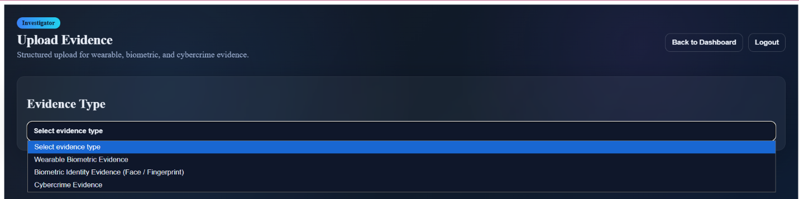
This validates the evidence uploaded by the investigator (all input fields, except the optional ones, must be filled according to the data types necessary). This helps in ensuring the evidence is stored in a correct and structured format.
- Stores evidence in database
- Records custody information
For example, checking if Case ID of a particular evidence is present.
This checks correct fields for the corresponding evidence types as:
- Wearable biometrics (proof tampering)
- Fingerprint to face biometric recognition
- Cybercrime classification

3. Analysis Lifecycle Module
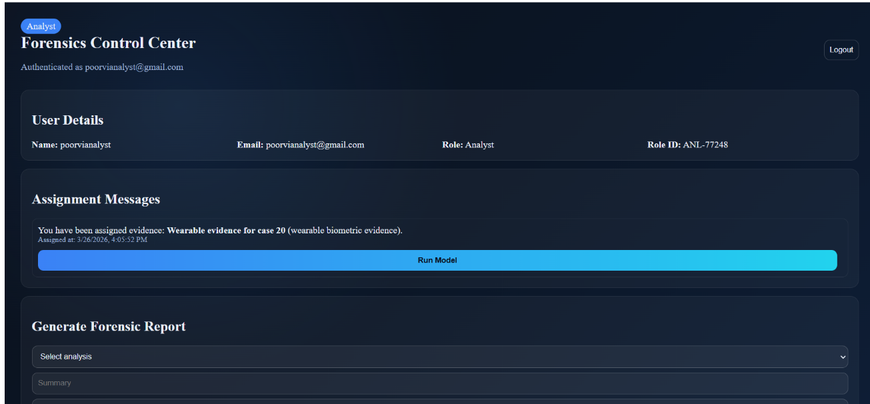
The forensic Analyst
- Starts analysis of the uploaded evidence
- Is assigned the task of analysis by the System Administrator
For each evidence, we Tracks Status, which is one the following - Pending / Running / Completed.
Example:
- Only assigned analyst can run analysis
- Admin can override
This helps in gaining full control about which one of all forensic analysts can perform analysis.

4. Machine Learning Inference Module
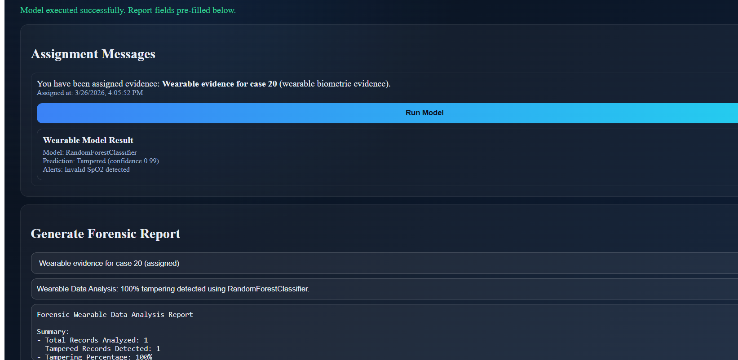
This is used for connecting the other parts of the system with three different ML models, that help the analysts in running models for analysis of evidences and generation of reports.
- Prepares data for ML model
- Calls Python ML script
- Gets prediction result
Example:
Input → wearable data
Output → normal / tampered + confidence

5. Report Generation Module
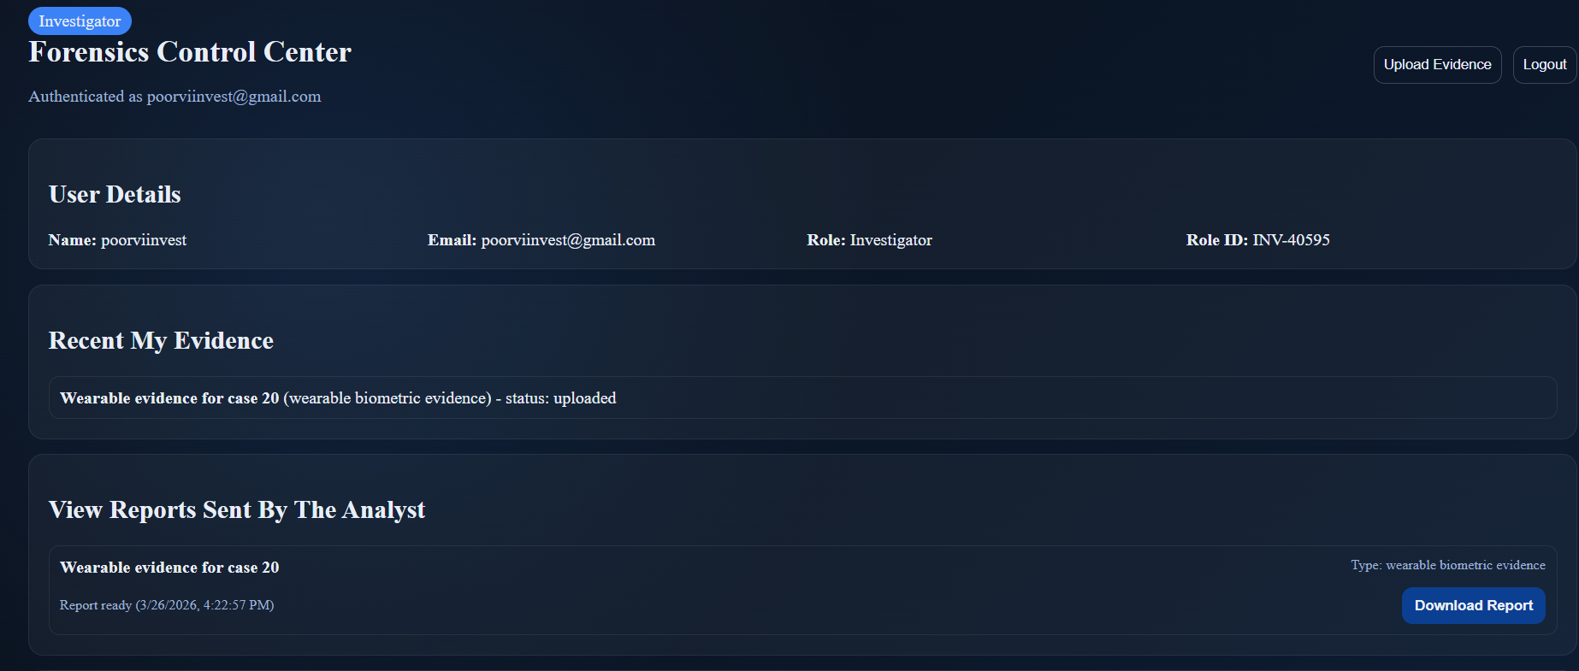
This module is for production of final investigation reports by the analyst, which are to be viewed by the corresponding forensic investigators.
- Creates forensic report
- Links report with evidence & analysis
- Controls report access
Example:
- Analyst generates report
- Investigator views report
6. Dataset Catalogue Module
- Stores available datasets
- Filters datasets (one of the three given are chosen)
Used in the user interface design, for selection of respective dataset as per the evidence uploaded.

7. Audit Logging Module
This module is used to ensure traceability and accountability which is necessary to make the forensic system and the evidence and reports secure, and free from external intrusion or tampering. This is done by keeping a track of all actions taken by each user. The module is being maintained by the system administrator. Nobody other than the system administrator can view the logs. No user has the access to edit logs/audits, not even the system administrator.
Example of Logs / Audits:
- Evidence upload
- Model execution
- Report generation

Interaction with Presentation Layer (UI)

Explaining how the UI talks to the Business Logic Layer:

UI → BLL Communication
UI sends frontend requests to backend APIs:
- POST /api/evidence
- GET /api/evidence/analyses/all
- POST /api/ml/run
- GET /api/reports
- GET /api/logs
This is an example of the Interaction Flow:
- Upload Evidence: UI Form → API → BLL validates → Store in DB → Response → UI updates
- Assign Analyst: UI → API → BLL updates assignment → UI shows assigned analyst
- Run ML Model: UI → API → BLL calls Python model → Result → UI shows prediction

Example output shown on the user’s side:
Model name, Tampered / Normal, Confidence score
- Generate Report: UI → API → BLL creates report → UI displays download option.

Error Handling
If there is some exception or issue with the code, for example:
- Missing fields
- Wrong role
- Model error
The BLL sends error, and the frontend UI shows a message, describing the error, and how it is to be handled.

Why BLL is Important

1. Consistency
All rules of the system are defined in one place, and the UI cannot bypass or ignore these rules.

2. Security
To enhance security mechanism, RBAC is used, by applying role-checks for every user who enters into the system. Data or services are provided to the users accordingly. This is helpful in preventing unauthorized access.

3. Auditability
All actions are logged or audited. This is very important for forensic systems. Only the system administrator has the required permissions to only view these logs, not even to edit them, to enhance security of the system.

4. Maintainability
If there is a change in rules, we just need to update the BLL, and there is no need to change anything in the frontend or the user interfaces.

